Steps followed in Deploying ELK Stack on Docker Container: Create an instance:

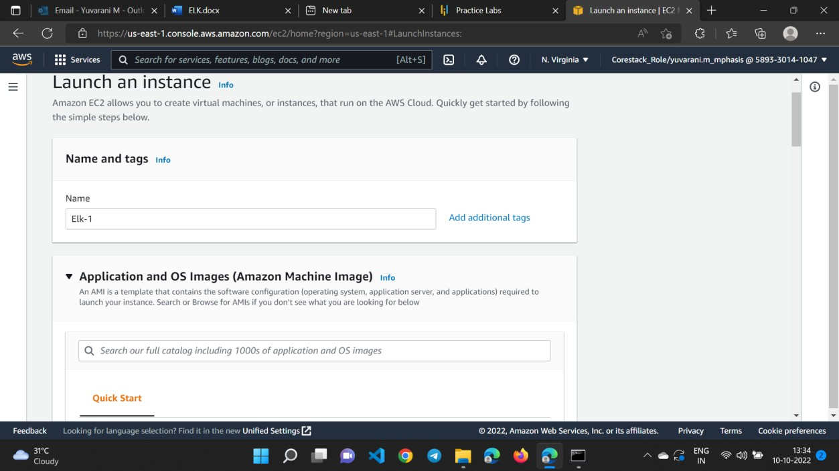

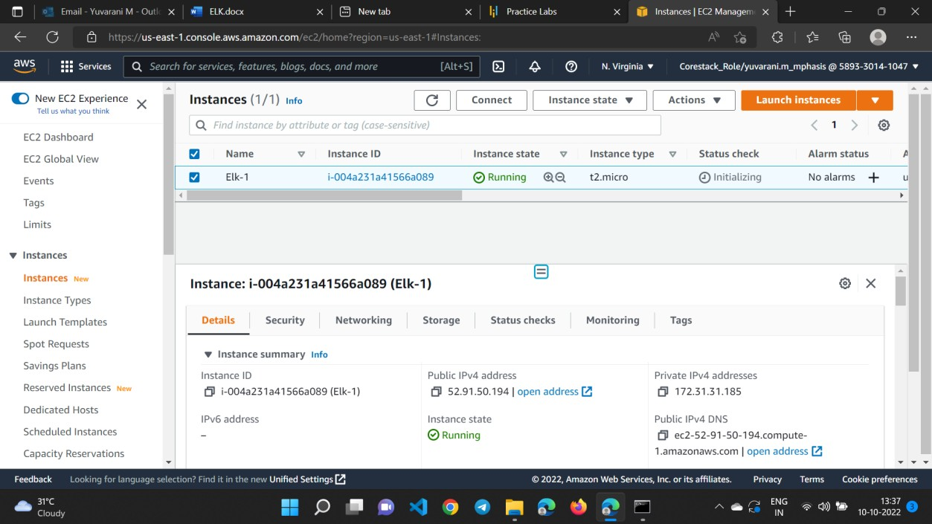

Create Docker:

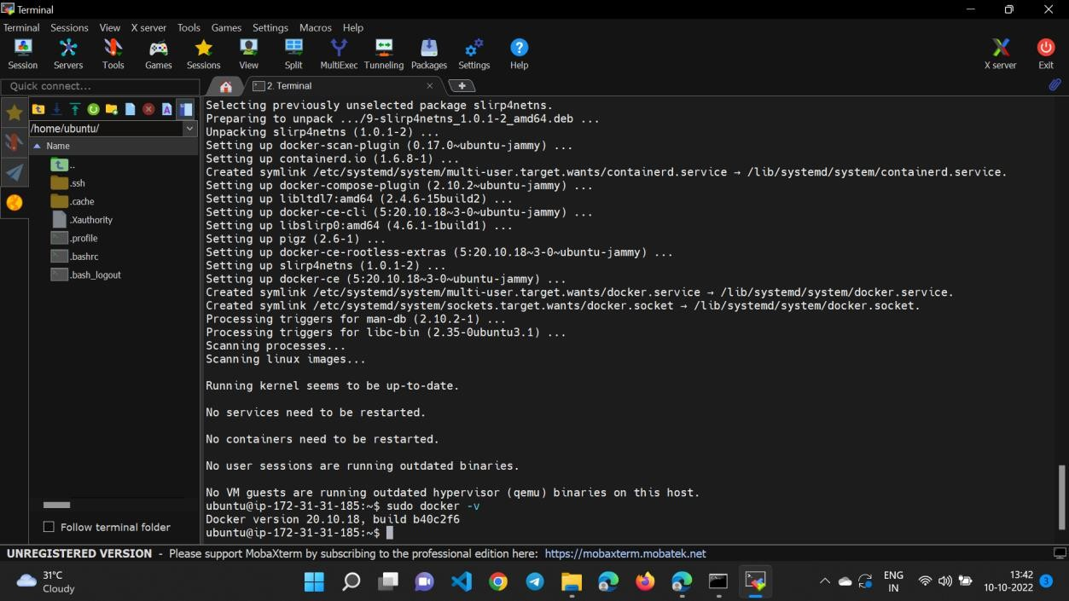

Install elastic search:

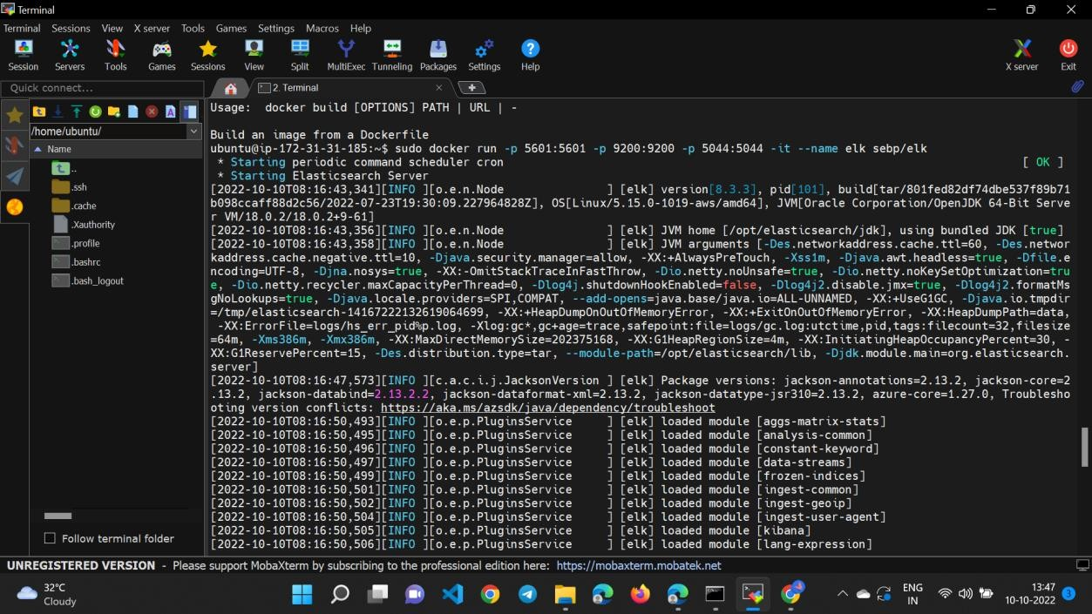

The command publishes the following ports:

* 5601 serves the Kibana web interface.
* 9200 for Elasticsearch JSON interface.
* 5044 for Logstash Beats interface.

The three ports are necessary for the stack to work correctly. Additionally, the following ports are exposed but not published:

* 9300 for the transport interface of Elasticsearch (expose with -p 9300:9300).
* 9600 for the Logstash monitoring API (expose with -p 9600:9600). Access the Kibana web interface with:

http://<host>:5601

